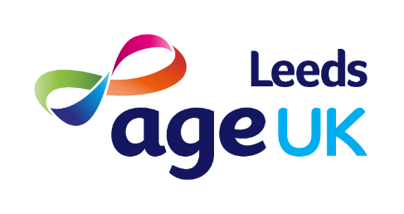
We are now launching our new Scams Prevention and Support Service.
The programme, funded by Lloyds Banking Group, will help to prevent older people from falling for scams by increasing their knowledge and confidence to recognise and deal with attempted scams. It will also provide support to older fraud victims recovering after an incident.
Older people can be particularly vulnerable to fraud and scams, which can have a serious emotional and financial impact, and can damage quality of life and wellbeing for many.
Sophisticated scams have been on the rise during the pandemic with criminals devising even more ways to target those they believe to be vulnerable. This means it’s even more vital to support those that may be at greater risk.
The service will be delivered in two parts:
Individual Advice Sessions:
We will work with people aged 50 or over who meet one or more of the following criteria:
- Those who may be classed as vulnerable or at risk of scams. This could include people that have been directly targeted by a scammer, people who are living alone, recently bereaved, are housebound or disabled, socially isolated or lonely people.
- Older people who have already been a victim of a scam. This group would include people who have sent money and may be struggling to stop responding to scams, those who may be in denial that they are being scammed or those who continue to respond to scams because of more in-depth issues such as mental health problems or social isolation.
- Older people who would find it difficult to attend one of our group awareness events because of mobility problems or other health conditions.
Awareness Talks:
- The talks can be delivered online, at our local Age UK Leeds office or across different locations in the community. We aim to reach older people from lots of different backgrounds.
- Attendees can be an older person, their family and friend or people working/ volunteering in organisations in their communities that have regular contact with vulnerable older people.
Get in touch and find out more
If you would like to arrange for an Awareness Talk, make a referral for a client for individual support or just find out more about the service please contact us on scamsservice@ageukleeds.org.uk or telephone 0113 389 3000.
Please note that referrals from external organisations will be required to complete a referral form, including consent from the client for the referral and for us to contact them. Completed forms should be sent to scamsservice@ageukleeds.org.uk

